Nama : Rizki Nur Fauzi

NIM :18090054

Kelas : 5B

**PRAKTIKUM 3**

1. Source Code

Matakuliah.php-> application/controller

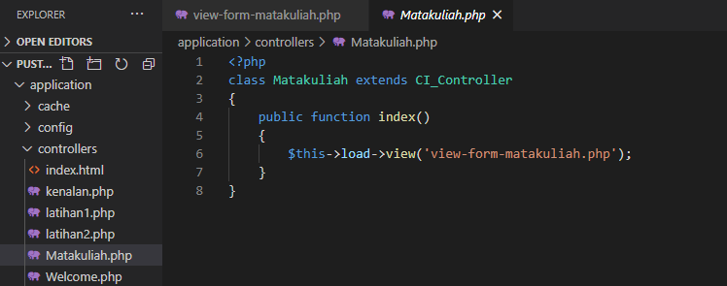

View-form-matakuliah.php->application/view

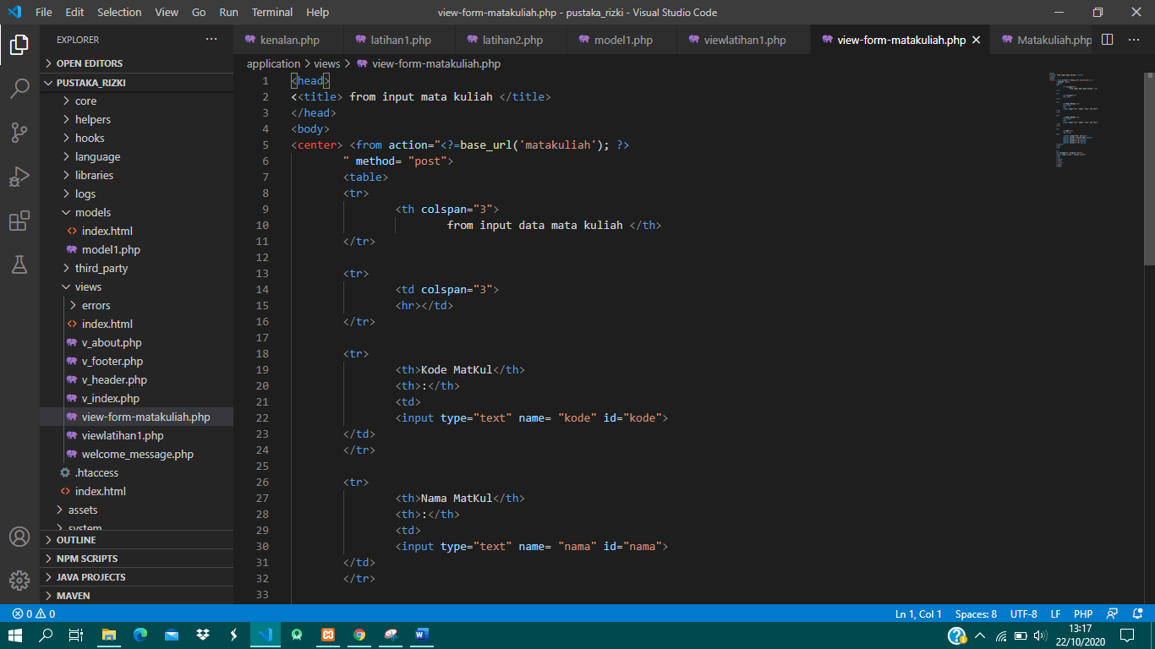

1. URL

http://localhost/pustaka_rizki/index.php/Matakuliah

1. Capture Hasil

